|  |  |
| --- | --- |
| *school-learn-study-hat-graduate-512.png* | ***Study*** |

Read Session 20, chapter 20.0, 20.1, 20.2:

[**http://www.ict.ru.ac.za/Resources/cspw/thinkcspy3/thinkcspy3.pdf**](http://www.ict.ru.ac.za/Resources/cspw/thinkcspy3/thinkcspy3.pdf)

And then do exercises: 20.8.1

|  |  |
| --- | --- |
| *6iporAnbT.jpg* | ***Serious exercises*** |

**Exercise 1**

Given the following dictionary:

inventory = {

'gold' : 500,

'pouch' : ['flint', 'twine', 'gemstone'],

'backpack' : ['xylophone', 'dagger', 'bedroll', 'bread loaf']

}

Try to do the followings:

* Add a key to inventory called 'pocket'.
* Set the value of 'pocket' to be a **list** consisting of the strings 'seashell', 'strange berry', and 'lint'.
* Then .remove('dagger') from the list of items stored under the **'backpack'** key.
* Add 50 to the number stored under the **'gold'** key.

**Exercise 2**

Write a program to count number occurrences in a list, with AND without using count() function

Example:



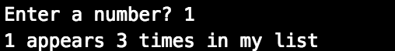

**Exercise 3**

Bacteria B **replicates** itself each 2 minutes, write a program that asks users to enter two numbers: the **initial B bacteria number** and a period of **time (in minutes).** Calculate and print out the **total number of B bacteria** after this period.

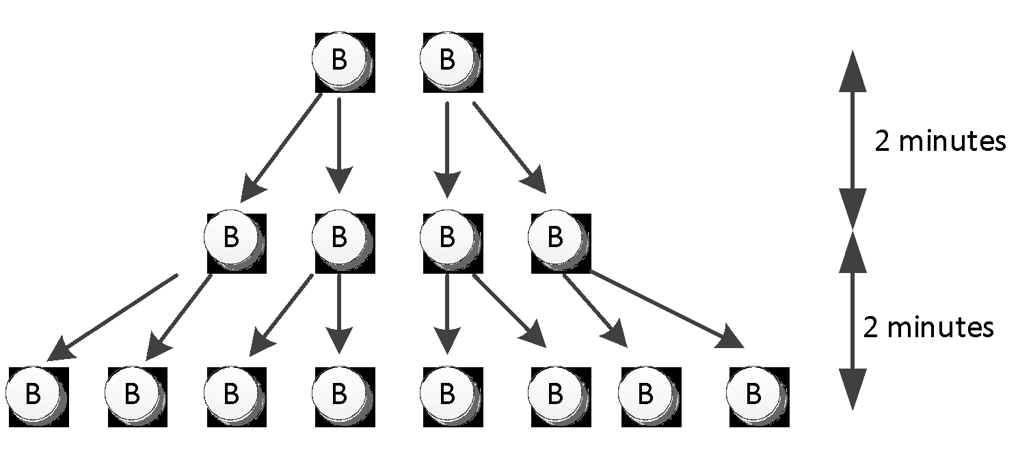

Expected screen output:

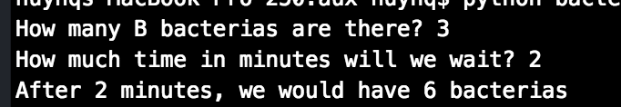

Or:

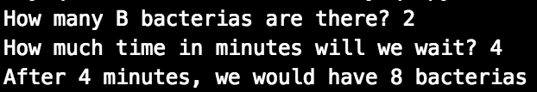

**Exercise 4**

1. (Optional) In Happy Farm, there are initially a couple of rabbits (female and male). This couple of the rabbits reproduces a new couple of rabbits each month. Each newborn rabbit couple becomes mature in one month and then gives a life to a new rabbit couple each month after. Write a program that calculates the number of pair of rabbit after 4 months.

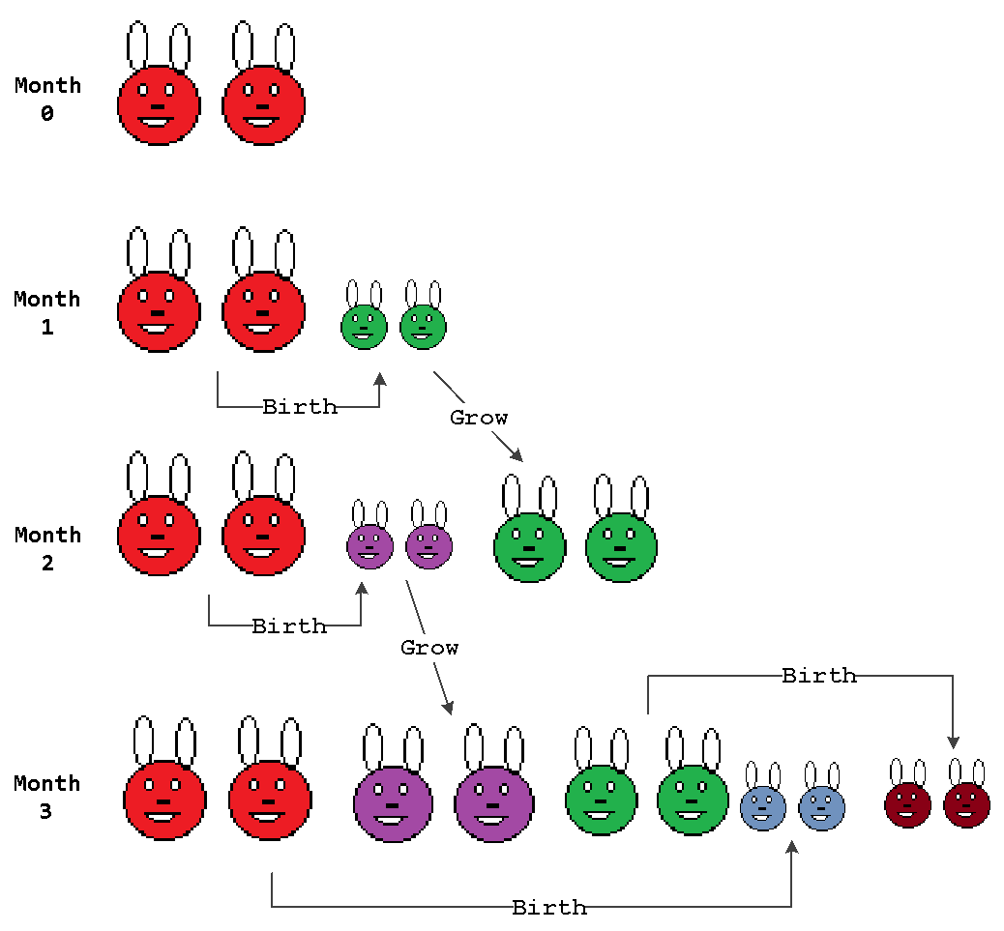

Expected screen output:

(Note that no user’s information needed)

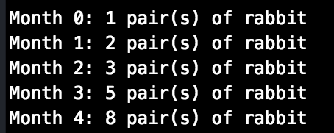

If you need hint, scroll to the last page

**Exercise 5 (optional):**

Create a new dictionary called prices using {} format like the example above.

Put these values in your prices dictionary:

* "banana": 4,
* "apple": 2,
* "orange": 1.5,
* "pear": 3

Create another dictionary called stock using {}:

Put these values in your stock dictionary

* "banana": 6,
* "apple": 0,
* "orange": 32,
* "pear": 15
* Loop through each key in prices. For each key, print out the key along with its price and stock information. Print the answer in the following format:
* apple
* price: 2
* stock: 0
* pear
* price: 3
* stock: 15
* Let's determine how much money you would make if you sold all of your food.
  + Create a variable called total and set it to zero.
  + Loop through the prices dictionaries. For each key in prices, multiply the number in prices by the number in stock. Print that value into the console and then add it to total.
  + Finally, outside your loop, print total.

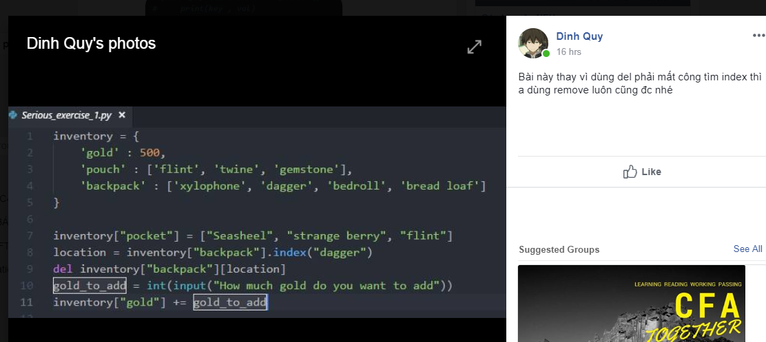Google “Fibonacci sequence”

